Christian Amsler, Regierungsrat
Vorsteher Erziehungsdepartement, Erziehungsdepartement, Herrenacker 3, CH-8200 Schaffhausen
Tel +41 52 632 71 95, Fax +41 52 632 76 00, e-Mail christian.amsler@ktsh.ch
Speech at the International Baccalaureate / Diploma Programme / Gratuation Ceremony
Gym Hall of the Secondary Building, 27. Mai 2016 / 15:30 Uhr
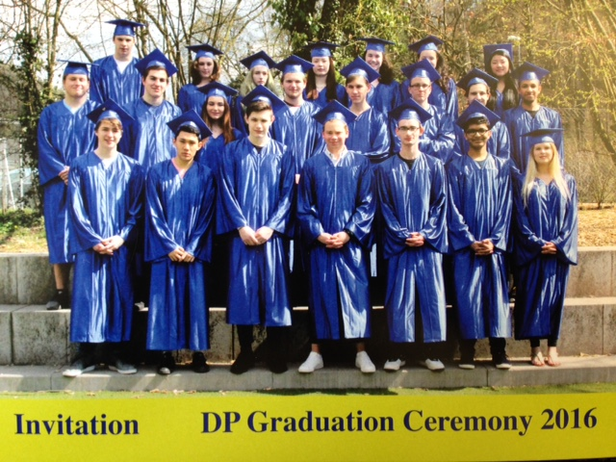

Dear ISSH Head Gundula
Dear Parents, Students, Staff and Friends of the ISSH

It is a great pleasure for me to be here this afternoon! First of all, let me deliver my most important message to you from the government of the Canton of Schaffhausen.
In the name of the governing council I would like to say to you, that it is a very great honor to congratulate warmly to your IB Diploma 2016.

We are very proud, yes even excited, to have the ISSH with us in the Schaffhausen region, this is so important for our economy.

I am also very pleased and honored that Gundula has asked me to say a few words as a member of the ISSH Board and also as Minister of Education in the Canton Schaffhausen.

Actually, with great interest, I have studied your IB and diploma program. You heard a lot about the world, about challenges and choices, values, systems, history, countries, about the nature and politics in a Globalized World. So, the world is now open for you for geeting more solid knowledge and learning stuff for your backpack. What a great and wonderful future!

So, for me as the minister of education, I think it was also quite important that the ISSH IB and Diploma program is mainly based on modern teaching and learning strategies and includes presentations, plenary discussion, project work, team tasks, workshops, and many more.

Great! I like that too and it is so important for your personal social competences and for your future work out in the world.

As a minister of the Schaffhausen government let me also say some words about our lovely region. I hope, that you will always wearing a piece of Schaffhausen in your heart, the so called “little paradise” at the border of the river Rhine.

Today, we are proud to say that Schaffhausen is an international business location. It is actually the achievement of many parties involved that so many international and well-known companies have chosen to have its locations right here in Schaffhausen. But we all have to work very hard in order to keep Schaffhausen such an attractive location and to become even more competitive especially on an international level.

Schaffhausen was mainly known as a location with traditional industrial production sites, then there was a structural change and Schaffhausen became a business location for sophisticated high tech firms and innovative service and production companies.

And it is still ongoing!

In order to create more jobs and to keep this very positive development process going, we need both, such as established companies of all sizes and as well as new, innovative companies from abroad. The main goal is to open up and diversify the whole area, that the local economy is no longer dependent on a few sectors and companies as it was until the nineties.

I am not only the Minister of Education but also the Minister of culture and sports! Here in Schaffhausen we have a very rich cultural agenda bursting with all sorts of cultural activities and attractions. We have some very interesting museums, every two years we celebrate the International Johann Sebastian Bach Festival, in these days we have the opportunity to spend wonderful days with fabulous Jazz music at the Schaffhauser Jazz Festival, then during the summer, - month of August, we have the fantastic "Stars in Town" Music Festival with popular music in the very heart of Downtown Schaffhausen with famous musicians from all over the world.

Next to the targets set on business development, the Canton of Schaffhausen also wants to become more and more an attraction for young families. Young families with kids appreciate the beautiful and unspoilt nature in our region and the excellent and safe schools.

Schaffhausen is definitely a very attractive place for living. Currently, we can observe an enormous boom and hype in the local real estate market and interesting building projects pop up everywhere, which clearly are the result of a strong demand in new residential and office buildings.

A strong focus is also put to a closer and better connection to the economic area of Zurich. At this point we started two years ago with the rail service from Schaffhausen to Zurich on a regularly base of every half hour.

Well, Schaffhausen, is located in the center and heart of Europe. With 40 Minutes, we are also very close to the airport of Zurich, which is an important flying Hub for most of the international airlines

We all here in our area hope very much that you will go to the countries, in which you will live and work, with a good impression and fond memories of our beautiful “little paradise” - Schaffhausen - at the border of the Rhine.

I wish you only the very best for now but also for all your hopes and achievements in the future – young leaders of the world!

We, including the two Boards of the ISSH, including your parents, congratulate you for what you have done here at the ISSH and also for what you will achieve in the future. We are all very proud of you and wish you all the best by entering the wide open world!

The former President of America Theodor Roosevelt said:

“Do What You Can, With What You Have, Where You Are”

Regierungsrat Christian Amsler, Schaffhausen, Mai 2016

